Research Grant Status Tracker

**Customer: Prof. Malek-Madani**

Email: [rmm@usna.edu](mailto:rmm@usna.edu)

**Technical Advisor: LCDR Kenney**

Email: [kenney@usna.edu](mailto:kenney@usna.edu)

Phone: (410)-293-6810

Apps Linking Midshipmen and Officers

Team 6

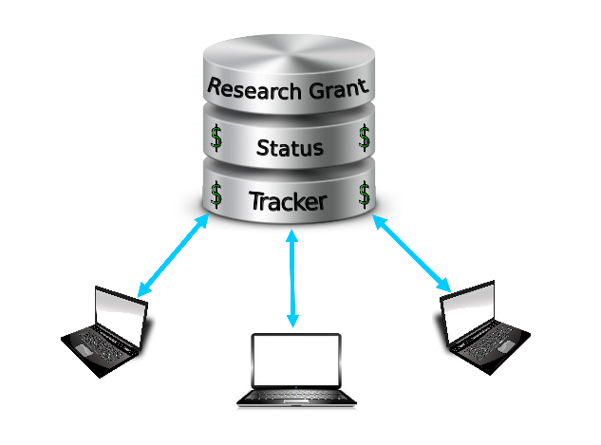

Arnold, Nick - IT

Coons, Coons - CS

Gibson, Scott - CS/QE

Pullig, Brandon - CS/IT

Hall, Micky - CS/IT (Team Leader)

**Customer’s initials**: __________ **Date initialed:** __________ “I have reviewed the Teams Capstone Proposal and am satisfied with its contents including, in particular, the team’s Acceptance-Testing-FocusedFunctional Requirements Trace Table. I understand that the team will be following the Agile Software Development approach and that I may (and am encouraged to) ask for the addition, removal, or modification of any functional or non-functional requirements and/or acceptance test cases at any time as the Capstone Project progresses.”

**Technical Advisor’s initials**: ___________ **Date initialed:** __________ Required only for teams whose Customer is not a faculty member in the Computer Science Department.